MOUNTING THE LIPSYNC

Contents

[Introduction 3](#_Toc32314396)

[Mounting to a Wheelchair 3](#_Toc32314397)

[Mounting Points 3](#_Toc32314398)

[Considerations 6](#_Toc32314399)

[Suppliers 10](#_Toc32314400)

[Commercial Assistive Technology Mounting 10](#_Toc32314401)

[On-Stage 10](#_Toc32314402)

[Advantages 10](#_Toc32314403)

[Drawbacks 10](#_Toc32314404)

[Sample Parts and Approximate Prices 10](#_Toc32314405)

[Loc Line 11](#_Toc32314406)

[Advantages 11](#_Toc32314407)

[Drawbacks 11](#_Toc32314408)

[Sample Parts and Approximate Prices 11](#_Toc32314409)

[Ablenet 12](#_Toc32314410)

[Advantages 12](#_Toc32314411)

[Drawbacks 12](#_Toc32314412)

[Sample Parts and Approximate Prices 12](#_Toc32314413)

[SnakeClamp 13](#_Toc32314414)

[Advantages 13](#_Toc32314415)

[Drawbacks 13](#_Toc32314416)

[Sample Parts and Approximate Prices 13](#_Toc32314417)

[Manfrotto 14](#_Toc32314418)

[Advantages 14](#_Toc32314419)

[Drawbacks 14](#_Toc32314420)

[Sample Parts and Approximate Prices 14](#_Toc32314421)

[LinkDelight 15](#_Toc32314422)

[Advantages 15](#_Toc32314423)

[Drawbacks 15](#_Toc32314424)

[Sample Parts and Approximate Prices 15](#_Toc32314425)

[Rehadapt 16](#_Toc32314426)

[Mobility Mount 16](#_Toc32314427)

[Advantages 17](#_Toc32314428)

[Disadvantages 17](#_Toc32314429)

[Sample Parts and Approximate Prices 17](#_Toc32314430)

[Mounting Assemblies 17](#_Toc32314431)

[LipSync 17](#_Toc32314432)

[Mounting Options Per Price Range 17](#_Toc32314433)

[Mobile Device 23](#_Toc32314434)

[No Mount 23](#_Toc32314435)

[Mount 23](#_Toc32314436)

[Combining LipSync and Mobile Device 23](#_Toc32314437)

[Suggestions for Assembling Mounts 25](#_Toc32314438)

[Sources 27](#_Toc32314439)

[Appendix A - Checklist for After Choosing a Mount 29](#_Toc32314440)

[Appendix B - Assembly Instructions for 3D Printed Clamp 30](#_Toc32314441)

[Appendix C - Assembly Instructions for DIY Mount 32](#_Toc32314442)

[Appendix D - Field of Vision Claculations 37](#_Toc32314443)

# Introduction

The LipSync is a mouth operated sip and puff joystick that enables people to use mobile devices such as a mobile phone, and other

The lightness of the LipSync as well as its compactness make it a great candidate for portable, wheelchair mounted applications but some considerations need to be taken when choosing a mounting option to ensure ease of use and safety of the user. This document details the considerations of how to mount the LipSync. Now that you have the LipSync, how can you mount it onto a wheelchair? What options are there for your mobile device? What are some of the considerations to have in mind when choosing a mounting option?

# Mounting Requirements

## Considerations

When choosing a mount, many things need to be taken into consideration to ensure the safety of the user. Below you'll find a complete detailed list of these considerations. For a quick checklist, refer to Appendix A Checklist for After Choosing a Mount.

1. Mounting at the sides can make doorways difficult to navigate. Modern wheelchairs are 24"-27" in width and a wheelchair accessible door is usually 32" therefore care should be taken when mounting to the side of the wheelchair. Ensure that the addition of the mount at the sides of the wheelchair **does not** extend beyond the wheelchair frame to avoid hitting the doorway and potentially dislodging the mount, thereby putting the user at a safety risk. There is also a risk of the mount getting caught in obstacles. The image below demonstrates a setup that must be avoided as it can be easily snagged on something or could potentially bump into surrounding objects.

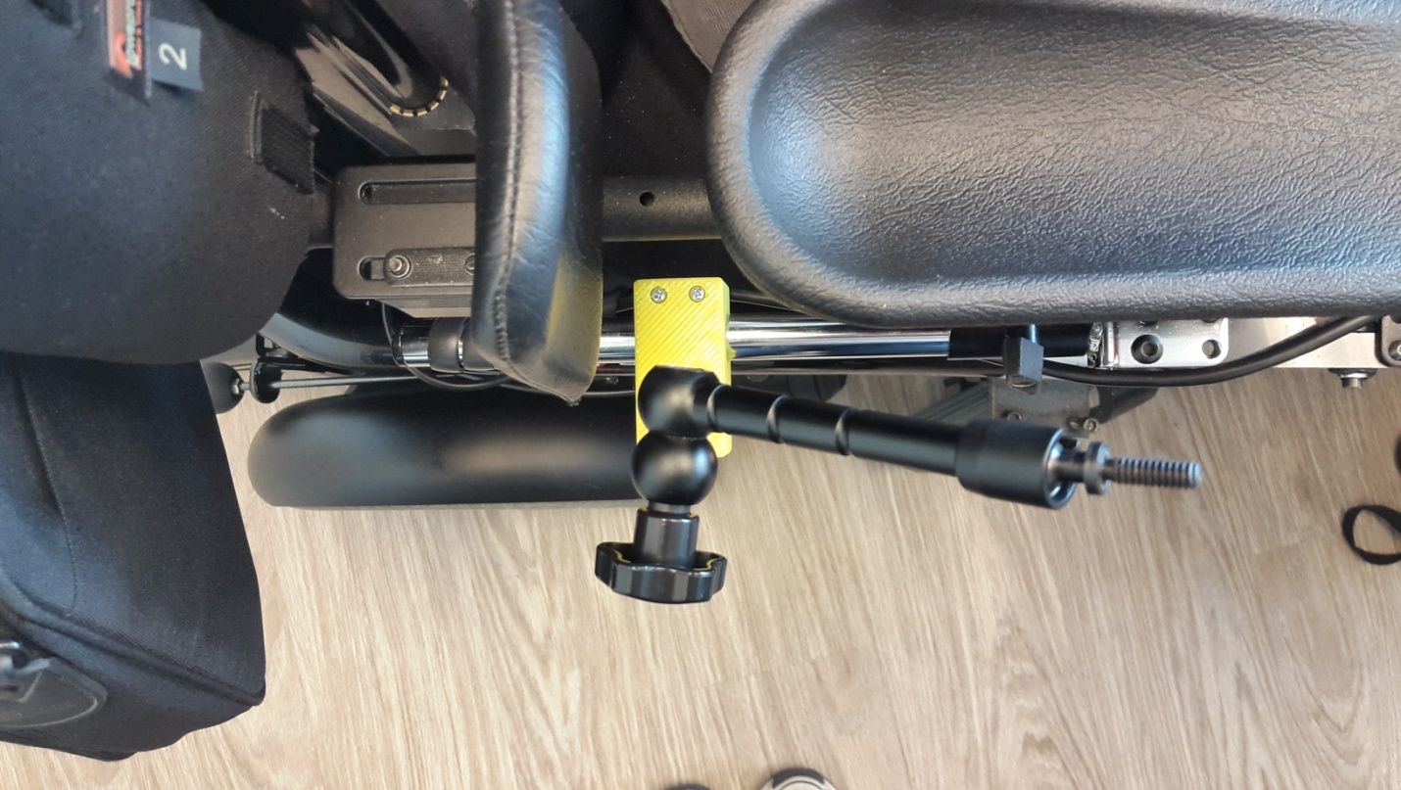

Knob protruding past wheelchair wheel

Figure - Image of an Unacceptable Mount Setup

1. Attaching a clamp vertically may cause slipping of the mount. Therefore care must be taken when mounting in this direction.
2. To increase the friction and avoid slipping of a clamp additional anti skid pads may be added. A common product that is used for this purpose is Dycem, which provides reels of non-slip mats and tapes. Another option is "Magic Wrap" used for plumbing repairs.
3. Care should be taken when mounting to the headrest especially in reclining chairs. In a reclined position, the mount is more likely to detach and fall. Some solutions to this problem is increasing the friction of the mount using methods described above. Another solution is to choose a mount that completely encases the rail of the headrest as shown in the image below.

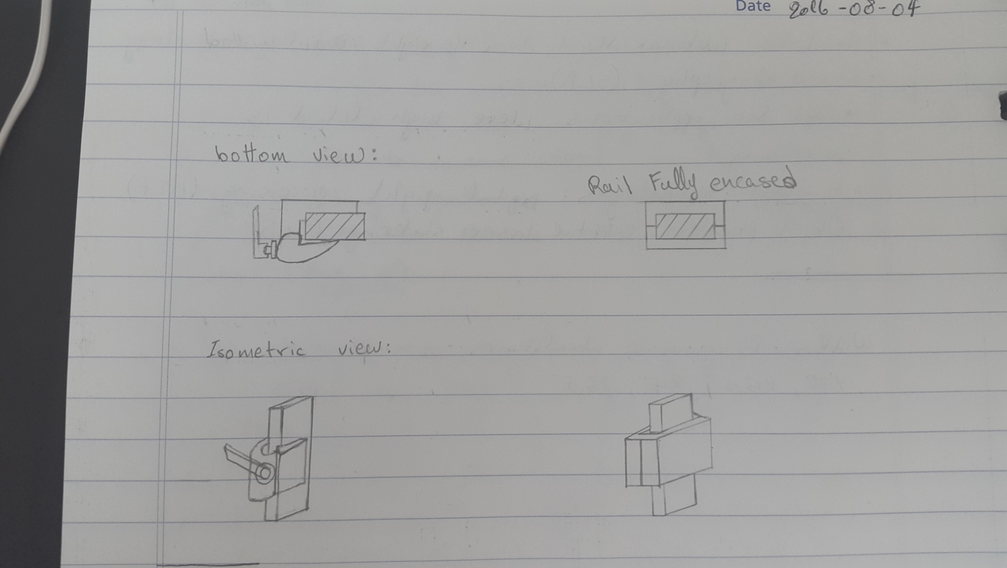

Figure 3 - A bottom and isometric view of a clamp that does not encase the rail vs. one that does

1. Wiring must be avoided to prevent faulty connections of the wheelchair devices.
2. Clearance around the wheels must be maintained to avoid detachment of the device or damage to the wheelchair.
3. In many wheelchairs, reclining causes a few components of the wheelchair to shift in position. Therefore, when choosing a mounting point check that there is clearance around the different components in both a reclined and non-reclined position.
4. When positioning the LipSync, care should be taken to ensure that the driving view of the user is not obstructed.
5. When positioning the LipSync, make sure that it is vertically aligned as described in Figure 4. Assemblies with goosenecks or ball and sockets at the top allow for positioning the LipSync vertically.

**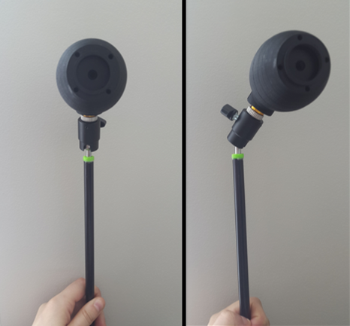**

Figure - Left: LipSync Positioned Vertically; Right: LipSync Positioned Non-vertically

1. When positioning the mobile device ensure that it is within viewing angle of the LipSync. The normal optical axis for a person in a sitting position is at 15° below eye level (Figure 4).

For example, if mounting a phone 35cm away from your face, the normal optical axis for a person in a sitting position is 15° below the 0° line, which translates to 7cm below eye level at that distance (Appendix D Field of Vision Claculations). The Limit of the range of vision is at 70-80°.

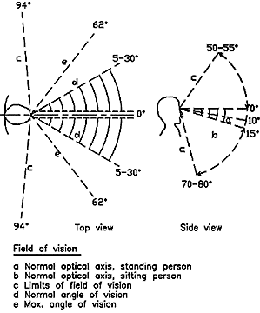

Figure - Field of Vision Range ((SOLIDERE) & (ESCWA), 1994)

1. When positioning the mobile device, make sure that it is adjusted to avoid glare from the sun. In some cases, it may be necessary to add an anti-glare screen protector to the mobile device available [here](https://www.amazon.ca/Tech-Armor-Anti-Glare-Anti-Fingerprint-Protectors/dp/B00IGISQUO).
2. On some power wheelchairs, the armrest can be lifted to allow for transferring the wheelchair user. Therefore, mounting to that side of the wheelchair in those cases is not recommended.
3. Mounting at the back of the wheelchair requires the mount to be very long compared to other mounting points. In this position the mount experiences a large amount of torque which could cause it to fail.

LipSync Mounting

# Mounting to a Wheelchair

## Mounting Points

Every wheelchair is different in terms of the points available for mounting. Below is a list of some common mounting points that are available on power wheelchairs. The sketches illustrate the locations of these mounting points on the wheelchair.

* + - 1. Headrest rail

1. Back of wheelchair
2. Armrest rail
3. Under chair cushion
4. Chair rail
5. Footplate

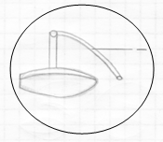

**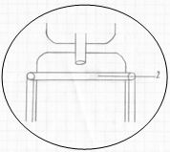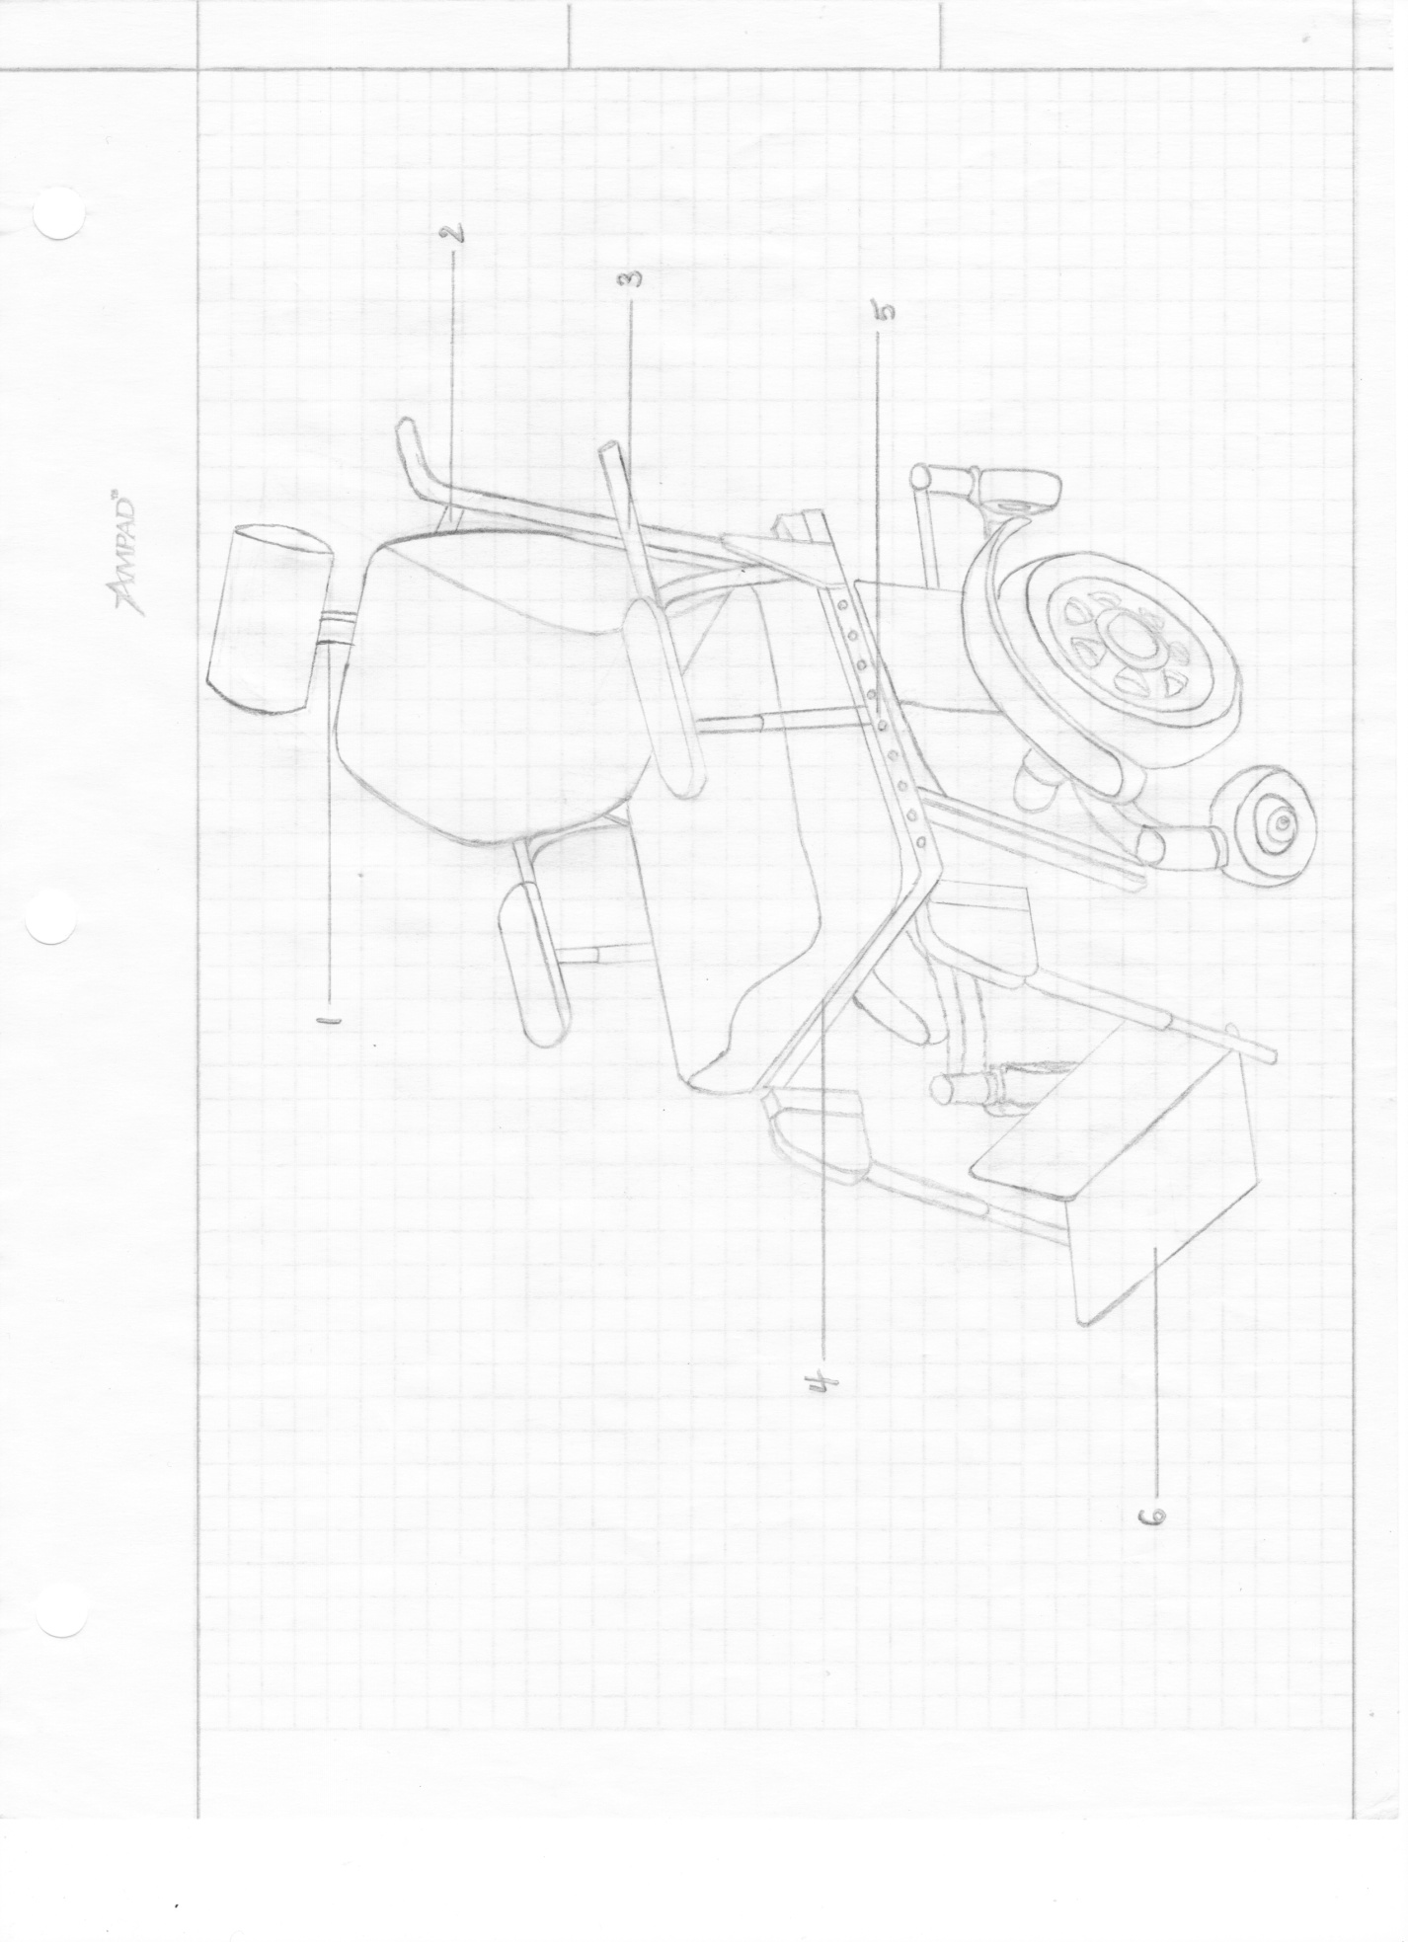**

**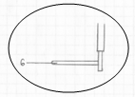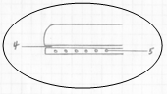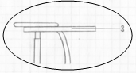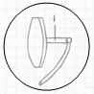**

Side View - Headrest

Figure - Sketch of Power Wheelchair and Views of its Components

Side View - Footplate

Back View - Wheelchair

Side View - Armrest

Side View - Chair Cushion and Rail

# Suppliers

The following list is meant to serve as an introduction to suppliers that offer mounts that could be used for the LipSync or a mobile device. The list is by no means exclusive since many other retailers sell mounts that work for our application either specific to assistive technology or not.

## Commercial Assistive Technology Mounting

### On-Stage

[**https://on-stage.com/**](https://on-stage.com/)

On-Stage manufactures a range of stands for musical instruments and microphones.

#### Advantages

1. It offers solutions at a lower price in comparison to the other suppliers.

#### Drawbacks

1. The goosenecks they offer are used for light weights and may sag under a heavy weight.

#### Sample Parts and Approximate Prices

|  |  |  |  |  |
| --- | --- | --- | --- | --- |
| **Part No.** | **Description** | **Supplier** | **Qty** | **Approximate Cost (CAD)** |
| MSA9030-19B | 19" Gooseneck, Black    (On-Stage, 19" Gooseneck) | Best Buy | 1 | $15 |
| MSA9030-13B | 13" Gooseneck, Black | Best Buy | 1 | $10 |
| MSA9030-06B | 6" Gooseneck, Black | Best Buy | 1 | $7 |
| MSA9505 | Posi-Lock Telescoping Mini-Boom  (On-Stage, Posi-Lok Telescoping Mini-Boom) | Best Buy | 1 | $30 |

### Loc Line

[**http://www.loc-line.com/**](http://www.loc-line.com/)

<http://www.modularhose.com/Assistive-Technology/>

Lockwood Products, Inc manufactures Loc-Line - a range of adjustable plastic hoses and adaptors originally developed for cooling purposes in machine tool operations. They now offer versions sp

#### Advantages

1. Hand adjustable for both position and length.
2. Unique ball and socket design, bending does not decrease the inside diameter.
3. Can be twisted along its axis.
4. Easily washable and is resistant to most common chemicals.
5. Reasonably priced and is widely available.
6. Hollow so a wire can be fed through it.
7. Able to use for both the phone and the LipSync device using one setup (Y fitting).

#### Drawbacks

1. Not suitable for applications where high loads are involved.

#### Sample Parts and Approximate Prices

\* EH Pope is a Canadian distributor

|  |  |  |  |  |
| --- | --- | --- | --- | --- |
| **Part No.** | **Description** | **Supplier** | **Qty** | **Approximate Cost (CAD)** |
| **Direct Mounting Solutions (to wheelchair)** | | | | |
| 510001 | Spring Clamp, 2", with integrated 3/4" ID Fixed Mount. Assembled.  b90730.jpg  (ModularHose, 510001) | Modular Hose | 1 | $9 |
| 512001 | Round Tube and Flat Surface Clamp Kit. b90751.jpg  (ModularHose, 512001) | Modular Hose | 1 | $39 |
| **Extension Lines** | | | | |
| 61501 | Hose Segments Pack for 3/4" ID System. Includes (2) 5" long segments. Approximately 1 foot. 61501p.jpg  (ModularHose, 61501) | EH Pope | 1 | $7 |
| 51801 | Hose Segments Pack for 1/2" ID System. Includes (2) 5" long segments. Approximately 1 foot. | EH Pope | 1 | $6 |

### Ablenet

[**https://www.ablenetinc.com/technology/mounting-cases**](https://www.ablenetinc.com/technology/mounting-cases)

#### Advantages

1. The mounts are all sold as a whole piece - no need to buy anything else.
2. Many available options from a gooseneck to mounting arms.

#### Drawbacks

1. Relatively expensive.

#### Sample Parts and Approximate Prices

|  |  |  |  |  |
| --- | --- | --- | --- | --- |
| **Part No.** | **Description** | **Supplier** | **Qty** | **Approximate Cost (CAD)** |
| - | Latitude Mounting Arm (quick release)  (Ablenet, Latitude Mounting Arm) | Ablenet | 1 | $440 |
| - | Gooseneck Mounting System | Ablenet | 1 | $250 |
| - | Friction Knob Universal Mounting System  (Ablenet, Friction Knob Universal Mounting System) | Ablenet | 1 | $325 |

### SnakeClamp

[**http://snakeclamp.com/Category/smartphone-snakeclamp-desk-stand-mount-holder-flexible-goosneck-arm**](http://snakeclamp.com/Category/smartphone-snakeclamp-desk-stand-mount-holder-flexible-goosneck-arm)

#### Advantages

1. You have the option of building your own mount.
2. Heavy duty goosenecks are available.

#### Drawbacks

1. Goosenecks may be unstable and sag under heavy weight.

#### Sample Parts and Approximate Prices

|  |  |  |  |  |
| --- | --- | --- | --- | --- |
| **Part No.** | **Description** | **Supplier** | **Qty** | **Approximate Cost (CAD)** |
| **Direct Mounting Solutions (to wheelchair)** | | | | |
| SCP-MC | Multiclamp  prod-multiclamp.jpg  (SnakeClamp, Mounting Bases) | SnakeClamp | 1 | $39 |
| **Extension Lines** | | | | |
| SCP-GN24 | 24" Heavy Duty Flexible Gooseneck Arm | SnakeClamp | 1 | $39 |
| SCP-GN18 | 18" Flexible Gooseneck Armgn18.jpg  (SnakeClamp, SCP-GN18 - 18" Flexible Gooseneck Arm) | SnakeClamp | 1 | $22 |
| SCP-GN18HD | 18" Heavy-Duty Flexible Gooseneck Arm | SnakeClamp | 1 | $24 |
| SCP-GN13B | 13" Flexible Gooseneck Arm, Black | SnakeClamp | 1 | $22 |
| SCP-GN09 | 9" Flexible Gooseneck Arm | SnakeClamp | 1 | $14 |
| SCP-RA12 | 12" Rigid Arm | SnakeClamp | 1 | $18 |

### Manfrotto

[**https://www.manfrotto.ca/**](https://www.manfrotto.ca/)

Manfrotto manufactures a range of clamps, adaptors and fixtures for mounting cameras, lighting devices and studio accessories.

#### Advantages

1. Load carrying capacity is relatively high.

#### Drawbacks

1. Cost is relatively high.
2. Electrically conductive.
3. Heavy, bulky and has a very 'industrial' appearance.

#### Sample Parts and Approximate Prices

|  |  |  |  |  |  |  |
| --- | --- | --- | --- | --- | --- | --- |
| **Part No.** | **Description** | **Load capacity (kg)** | **Max length (mm)** | **Supplier** | **Qty** | **Approximate Price (CAD)** |
| **Direct Mounting Solutions (to wheelchair)** | | | | | | |
| 171 | Mini clamp | 1 | - | Manfrotto | 1 | $40 |
| 035 | Super Clamp | 15 | - | Manfrotto | 1 | $57 |
| 635 | Quick Action Super Clamp | 15 | - | Manfrotto | 1 | $70 |
| **Extension Lines** | | | | | | |
| 244N | Variable friction arm (Manfrotto, Variable Friction Magic Arm without Camera Bracket) | 3 | 530 | Manfrotto | 1 | $200 |
| 237 | Flex arm. ID 13mm.  (Manfrotto, Flex Arm for Super Clamp) | 0.3 | 550 | Manfrotto | 1 | $50 |
| 237 HD | Heavy duty flex arm. ID 18mm. | 0.5 | 550 | Manfrotto | 1 | $60 |
| 196AB-2 | Single articulated arm: 2 sections  (Manfrotto, 2-Section Single Articulated Arm without Camera Bracket) | 1.5 | 605 | Manfrotto | 1 | $55 |

### LinkDelight

<http://linkdelight.com/en/.html>

LinkDelight offers a range of photography equipment.

#### Advantages

1. Offers compact and small mounts.

#### Drawbacks

1. Mainly aimed at the photography industry therefore some adapters need to be purchased.

#### Sample Parts and Approximate Prices

|  |  |  |  |  |
| --- | --- | --- | --- | --- |
| **Part No.** | **Description** | **Supplier** | **Qty** | **Approximate Cost (CAD)** |
|  | 11" Magic Adjustable Arm for Lilliput Monitor / LED Light Video Monitor615m666VvxL._SL1001_.jpg  (Amazon, Neewer® 11 Inch Adjustable Friction Power Articulating Magic Arm for DSLR Camera Rig / LCD Monitor / DV Monitor / LED Lights / flash light) | Amazon | 1 | $15 |
|  | 11" Articulating Magic Arm + Small Clamp Crab Pliers + Gopro Adapter+ Stainless Steel Thumber Screw Accessory Kit | LinkDelight | 1 | $24 |
|  | Digital Camera Camcorder Mini Ballhead 1/4" Screw Thread Base  (LinkDelight) | LinkDelight | 1 | $6 |
|  | Mini Ball Head with Lock and Hot Shoe Adapter Camera | Amazon | 1 | $5 |

### Rehadapt

<https://rehadapt.com/>

#### Advantages

#### Disadvantages

#### Sample Parts and Approximate Prices

### Mobility Mount

<http://www.mobilitymount.com/>

Mobility Mount provides mounts specifically for wheelchair users. Its uniqueness lies in the fact that the base of the mount is held under the seat cushion. Many adapters are available to allow for mounting multiple devices.

#### Advantages

1. Mount sits under chair cushion therefore no mounting points necessary.

#### Disadvantages

1. Expensive to buy.

#### Sample Parts and Approximate Prices

|  |  |  |  |  |
| --- | --- | --- | --- | --- |
| **Part No.** | **Description** | **Supplier** | **Qty** | **Approximate Cost (CAD)** |
| MM01 | Base with tube | Mobility Mount | 1 | $320 |
| MT | Multi Table 10X14 with no slip | Mobility Mount | 1 | $155 |
| TC | Tablet Configuration for table | Mobility Mount | 1 | $115 |

# Mounting Assemblies

Below you'll find some wheelchair mounting options for the LipSync, a mobile device, or the combination of both. Endless setups may be assembled to fit a user's needs. Some setups may be more convenient than others depending on the considerations listed in the previous sections. Some of these components can be purchased from other suppliers.

## LipSync

The LipSync can be mounted in several different ways:

The LipSync housing has a 1

The LipSync has a standard 5/8"-27 thread female connection. The mounting options below include a 5/8"-27 thread male connection in order to connect to the LipSync.

### Mounting Options Per Price Range

#### $0 - $49

Most of the options below include a 3D printed clamp which contributes to the reduced price. The downside of using 3D printed parts is the reduction in the strength of the component and the likelihood of it breaking if used to hold up a heavy weight.

For the assembly instructions of the 3D Printed Clamp refer to Appendix B Assembly Instructions for 3D Printed Clamp.

For assembly instruction of the DIY Mount refer to Appendix C Assembly Instructions for DIY Mount.

*Note: There are two possible assemblies for the DIY Mount. A Mini Ball Head with Lock may be used in cases where the articulating arm and the arrow shafts do not provide enough flexibility to position the LipSync vertically. Steps for both options are included below.*

|  |  |  |  |  |  |
| --- | --- | --- | --- | --- | --- |
| **Part No.** | **Description** | **Qty** | **Supplier** | **Approximate Cost (CAD)** | **Total** |
| **Option 1 - DIY Mount** | | | | | |
|  | 3D Printed Clamp + Nuts and Bolts | 1 | - | $3 | $3 |
|  | Female 1/4"-20 to 5/8"-27 Male 2 Piece Mic Adapter | 1 | Amazon | $9 | $9 |
|  | 11" Inch Friction Articulating Magic Arm for Camera DSLR | 1 | Amazon | $14 | $14 |
|  | 3D Printed 1/4-20 threaded insert | 1 | - | $0 | $0 |
|  | Arrow shaft | 1 | Local Archery Store/Walmart | $7 | $7 |
|  | 3D printed Disk Gear + Nut and Bolt | 1 | - | $2 | $2 |
|  | 3D Printed 3/8-16 threaded holder | 1 | - | $0 | $0 |
| *For the second possible assembly* | | | | | |
|  | *Mini Ball Head with Lock and Hot Shoe Adapter Camera* | *1* | *Amazon* | *$5* | *$5* |
|  | *1/4 male to 3/8 male adapter* | *1* | *Amazon* | *$7* | *$7* |
|  | *3/8 female to 5/8 male adapter* | *1* | *Amazon* | *$7* | *$7* |
|  |  |  |  | **TOTAL** | **$35 *(Or $54)*** |

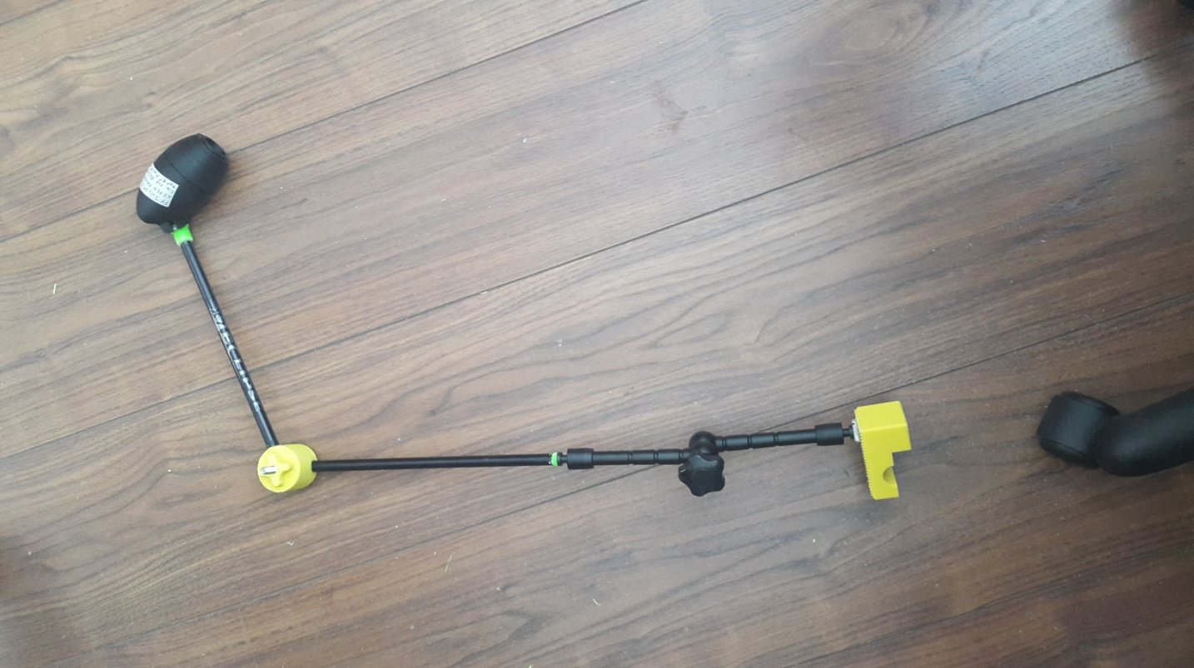

Figure 6 - From Left to Right: 3D Printed Clamp, Adapter, Articulating Arm, 3D Printed Adapter, Arrow Shaft, Disk Gear & Hand Knob, Arrow Shaft, 3D Printed Adapter, LipSync

|  |  |  |  |  |  |
| --- | --- | --- | --- | --- | --- |
| **Option 2** | | | | | |
|  | 3D Printed Clamp + Nuts and Bolts | 1 | - | $3 | $3 |
|  | 1/4" Male To 3/8" Male Thread Adapter | 1 | Amazon | $7 | $7 |
|  | 3/8" Female to 5/8" Male thread adapter | 1 | Amazon | $7 | $7 |
| MSA9030-19B | 19" Gooseneck, Black | 1 | Best Buy | $15 | $15 |
| MSA9030-13B | 13" Gooseneck, Black | 1 | Best Buy | $10 | $10 |
|  |  |  |  | **TOTAL** | **$43** |

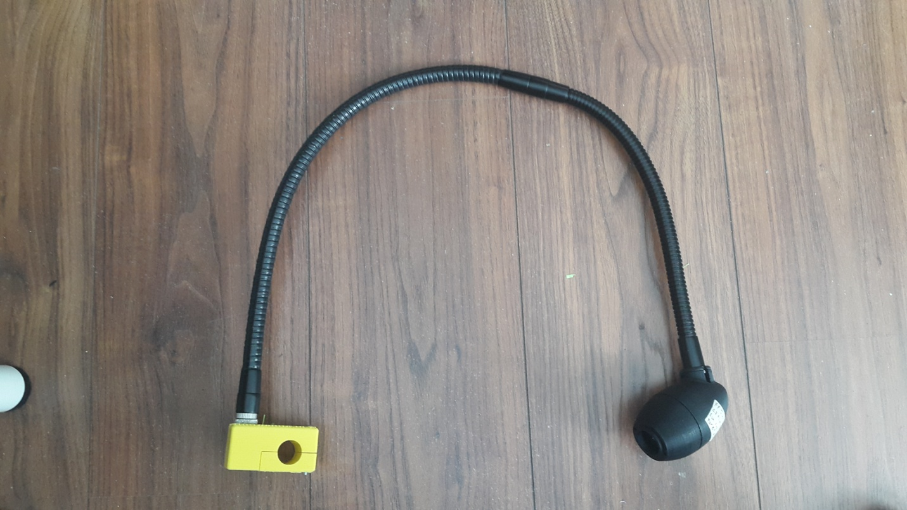

Figure 7 - From Left to Right: 3D Printed Clamp, Adapters, 19" Gooseneck, 13" Gooseneck, LipSync

|  |  |  |  |  |  |
| --- | --- | --- | --- | --- | --- |
| **Option 3** | | | | | |
|  | 11" Articulating Magic Arm + Small Clamp Crab Pliers + Gopro Adapter+ Stainless Steel Thumber Screw Accessory Kit | 1 | Link Delight | $24 | $24 |
|  | Female 1/4"-20 to 5/8"-27 Male 2 Piece Mic Adapter | 1 | Amazon | $9 | $9 |
|  | 19" Gooseneck, Black | 1 | Best Buy | $15 | $15 |
|  |  |  |  | **TOTAL** | **$48** |

#### $50-$99

The options below increase in price due to the use of a commercial clamp (with the exception of option 2). The price is still otherwise competitive compared to other options due to the fact that the parts used are not necessarily meant for assistive technology applications. For instance, as mentioned in the previous section (Suppliers), Loc-Line was originally developed for cooling purposes for machine tool operations.

|  |  |  |  |  |  |
| --- | --- | --- | --- | --- | --- |
| **Part No.** | **Description** | **Qty** | **Supplier** | **Approximate Cost (CAD)** | **Total** |
| **Option 1** | | | | | |
|  | Clamp with standard stud | 1 | Amazon | $28 | $28 |
| MSA9030-19B | 19" Gooseneck, Black | 1 | Best Buy | $15 | $15 |
| MSA9030-13B | 13" Gooseneck, Black | 1 | Best Buy | $10 | $10 |
|  |  |  |  | **TOTAL** | **$53** |

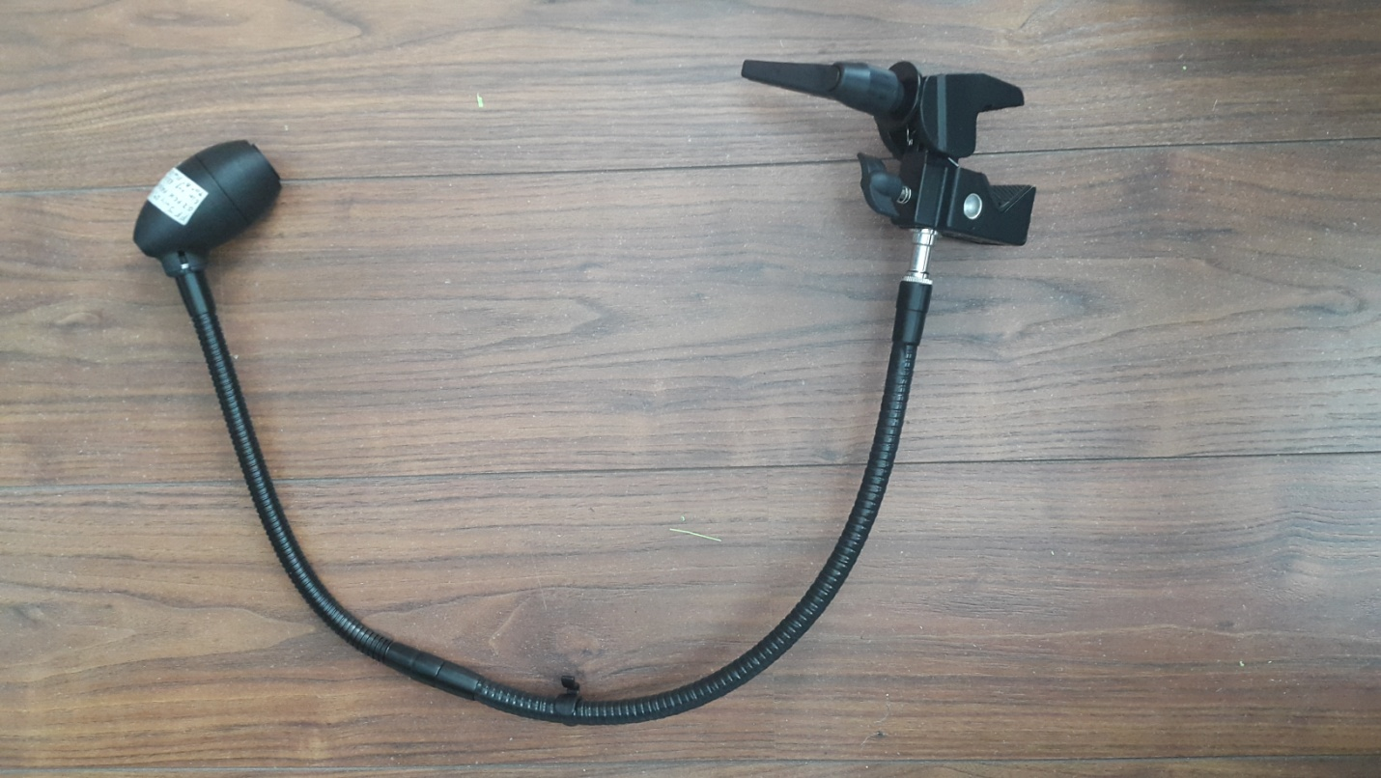

Figure 8 - From left to right: Super Clamp, Standard Stud, 19" Gooseneck, 13" Gooseneck, LipSync

|  |  |  |  |  |  |
| --- | --- | --- | --- | --- | --- |
| **Option 2** | | | | | |
|  | 3D Printed Clamp+Nuts and Bolts | 1 | - | $3 | $3 |
|  | 1/4" Male To 3/8" Male Thread Adapter | 1 | Amazon | $7 | $7 |
|  | 3/8" Female to 5/8" Male thread adapter | 1 | Amazon | $7 | $7 |
| MSA9505 | Posi-Lock Telescoping Mini-Boom | 1 | Amazon | $30 | $30 |
| MSA9030-19B | 6" Gooseneck, Black | 1 | Best Buy | $7 | $7 |
|  |  |  |  | **TOTAL** | **$54** |

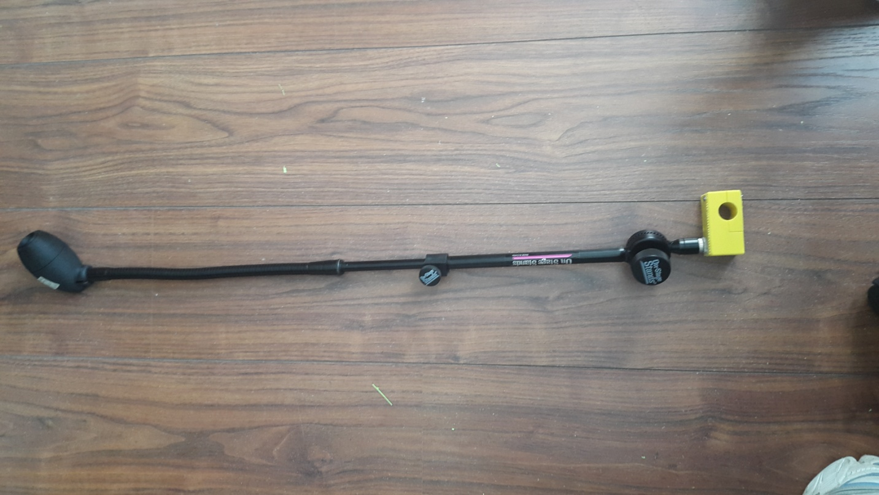

Figure 9 - From Left to Right: 3D Printed Clamp, Adapters, Posi-Lock Telescoping Mini-Boom, 13" Gooseneck, LipSync

|  |  |  |  |  |  |
| --- | --- | --- | --- | --- | --- |
| **Option 3** | | | | | |
| 512001 | Round Tube and Flat Surface Clamp Kit. (see above) | 1 | Modular Hose | $39 | $39 |
| 61501 | Loc-Line Hose Segments Pack for 3/4" ID System. Includes (2) 5 3/4" segments. Approximately 1 foot. (see above) | 1 | EH Pope | $7 | $7 |
| 51801 | 1/2" Hose, one foot, in Black (51801-BLK) - 1/2" Black Loc-Line | 1 | EH Pope | $6 | $6 |
| 61508 | 3/4" to 1/2" Adapter in Black (61508-BLK) - Black Hose | 1 | EH Pope | $3 | $3 |
| 51805 | 1/2" NPT Connector in Black (51805-BLK) - 1/2" Black Loc-Line | 1 | EH Pope | $1 | $1 |
|  |  |  |  | **TOTAL** | **$56** |

|  |  |  |  |  |  |
| --- | --- | --- | --- | --- | --- |
| **Option 4** | | | | | |
|  | Clamp with standard stud | 1 |  | $28 | $28 |
| MSA9505 | Posi-Lock Telescoping Mini-Boom | 1 | Amazon | $29 | $29 |
| MSA9030-19B | 13" Gooseneck, Black | 1 | Best Buy | $10 | $10 |
|  |  |  |  | **TOTAL** | **$67** |

#### $100+

These assemblies are used in industries such as the assistive technology industry or the photography industry. Their robustness, weight capacity and industrial use drive their prices up.

|  |  |  |  |  |  |
| --- | --- | --- | --- | --- | --- |
| **Part No.** | **Description** | **Qty** | **Supplier** | **Approximate Cost (CAD)** | **Total** |
| **Option 1** | | | | | |
| 035 | Super Clamp | 1 | Manfrotto | $57 | $57 |
| 237 HD | Heavy duty flex arm. ID 18mm. | 1 | Manfrotto | $50 | $50 |
|  | Female 1/4"-20 to 5/8"-27 Female Adapter | 1 | Amazon | $9 | $9 |
|  |  |  |  | **TOTAL** | **$116** |

|  |  |  |  |  |  |
| --- | --- | --- | --- | --- | --- |
| **Option 2** | | | | | |
|  | Clamp with standard stud | 1 | Amazon | $28 | $28 |
| 244N | Variable friction arm | 1 | Manfrotto | $210 | $200 |
|  | 1/4" To 3/8" Thread Adapter | 1 | Amazon | $9 | $9 |
|  | 5/8" Male to 3/8" Female Microphone Mic Stand Adapter | 1 | Amazon | $3 | $3 |
|  |  |  |  | **TOTAL** | **$240** |

## Mobile Device

### No Mount

In some cases, the mobile device may be placed on the user’s lap, the lap tray mounted on their wheelchair, or on a table in front of the user. In this case there is no need for a mount. A stand may be used to adjust the viewing angle of the phone.

### Mount

Most phone mounts have a standard 1/4"-20 female thread. Therefore, many mobile device holders may be selected in combination with the LipSync mounting options listed in the previous section (LipSync). The changes that need to be made relate to adding an adapter with a 1/4"-20 male thread. One potential option for a phone mount assembly is listed in the table below.

|  |  |  |  |  |  |
| --- | --- | --- | --- | --- | --- |
| **Part No.** | **Description** | **Qty** | **Supplier** | **Approximate Cost (CAD)** | **Total** |
|  | Mudder Universal Smartphone Holder Mount Adapter for Monopod Tripod Selfie Stick with Double Screw Head, Black    (Amazon, Mudder Universal Smartphone Holder Mount Adapter for Monopod Tripod Selfie Stick with Double Screw Head, Black) | 1 | Amazon | $13 | $13 |
|  | Thread Adapter Microphone Stand 5/8"-27 Female to 1/4"-20 Male f**o**r Camera Monitor | 1 | Amazon | $9 | $9 |
| MSA9030-19B | 19" Gooseneck, Black | 1 | Best Buy | $15 | $15 |
|  | Clamp with standard stud | 1 | Amazon | $28 | $28 |
|  |  |  |  | **TOTAL** | **$65** |

### Combining LipSync and Mobile Device

There are some options to combine both the LipSync and a mobile device into one mount assembly setup. The idea of combining the LipSync and a mobile device simplifies the mount assembly process since it requires choosing only one mounting point. Combining the two systems also allows for a reduction in price since only one clamp is used. Two possible combinations were assessed and will be detailed below.

The first option includes the Loc Line hoses. Since a Y fitting is available, a system using these hoses can be formed to attach both a mobile device and the LipSync. The table below provides a complete assembly.

|  |  |  |  |  |  |
| --- | --- | --- | --- | --- | --- |
| **Part No.** | **Description** | **Qty** | **Supplier** | **Approximate Cost (CAD)** | **Total** |
| 512001 | Round Tube and Flat Surface Clamp Kit. | 1 | Modular Hose | $39 | $39 |
| 61501 | Loc-Line Hose Segments Pack for 3/4" ID System. Includes (2) 5 3/4" segments. Approximately 1 foot. (see above) | 2 | EH Pope | $7 | $14 |
| 51801 | 1/2" Hose, one foot, in Black (51801-BLK) - 1/2" Black Loc-Line | 1 | EH Pope | $6 | $6 |
| 61511 | Loc-Line Y Fitting for 3/4" ID System.  (Pope) | 2 | EH Pope | $4 | $4 |
| 61508 | 3/4" to 1/2" Adapter in Black (61508-BLK) - Black Hose | 1 | EH Pope | $3 | $3 |
| 570009 | Extra deep V-tabs for tabX tablet holder.  (Hose) | 1 | Modular Hose | $24 | $24 |
| 51805 | 1/2" NPT Connector in Black (51805-BLK) - 1/2" Black Loc-Line | 1 | EH Pope | $1 | $1 |
|  |  |  |  | **TOTAL** | **$91** |

The second option was developed for using goosenecks. This option includes a 3D printed bracket with 2 holes for the goosenecks. The image below shows the bracket holding 1 gooseneck. The other hole is meant to support another gooseneck

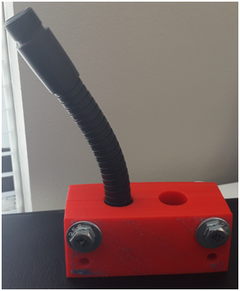

Figure 10 - 3D Printed Bracket Holding a Gooseneck

The files needed to 3D print the bracket can be found [here](file:///C:\Users\Jake%20Mclvor\Dropbox\Makers%20Making%20Change\Projects\LipSync\Mounting\Main%20Mounting%20Doc%20&%203D%20Printing%20Docs\3D%20Printing%20Bracket.docx).

|  |  |  |  |  |  |
| --- | --- | --- | --- | --- | --- |
| **Part No.** | **Description** | **Qty** | **Supplier** | **Approximate Cost (CAD)** | **Total** |
|  | Clamp with standard stud | 1 | Amazon | $28 | $28 |
|  | 3D printed bracket | 1 |  | $3 | $3 |
| MSA9030-19B | 19" Gooseneck, Black | 2 | Best Buy | $15 | $30 |
| MSA9030-13B | 13" Gooseneck, Black | 1 | Best Buy | $10 | $10 |
|  |  |  |  | **TOTAL** | **$71** |

## Suggestions for Assembling Mounts

1. Tape some anti-skid pads like Dycem pads or "Magic Wrap" to increase the friction of the clamps and reduce their rotation about the tube.
2. If two assembly pieces are used, such as two goosenecks, glue them together at the attachment point to avoid separation or rotation.
3. Some of the problems associated with Loc-Line and goosenecks is the instability and their tendency to sag after continuous use. This could be solved using rescue tape, electrical tape or "Magic Wrap" wrapped around the pieces. Another solution is to add a stiff wire to the inside of the parts.
4. Goosenecks are a good option for small sections, but may become unstable as the length increases and may sag under their own weight. Therefore, it is not advisable to use goosenecks when the mounting point is further away from the user, such as the back of the wheelchair.
5. When using Loc Line, use the 3/4" tubes as the base to provide stability and stiffness to the setup. 1/2" tubes may be used at the top of the assembly.

# Sources

(SOLIDERE), L. C., & (ESCWA), U. N. (1994). Field of Vision Range. *Accessibility for the Disabled* .

Ablenet. (n.d.). *Friction Knob Universal Mounting System*. Retrieved from ablenet: https://www.ablenetinc.com/technology/mounting-cases/friction-knob-universal-mounting-system

Ablenet. (n.d.). *Latitude Mounting Arm*. Retrieved from ablenet: https://www.ablenetinc.com/technology/mounting-cases/latitude-mounting-arm

Amazon. (n.d.). *Mudder Universal Smartphone Holder Mount Adapter for Monopod Tripod Selfie Stick with Double Screw Head, Black*. Retrieved from Amazon: https://www.amazon.ca/Mudder-Universal-Smartphone-Adapter-Monopod/dp/B00WTOHEBI/ref=pd\_rhf\_se\_s\_cp\_2?ie=UTF8&psc=1&refRID=R0SW3S8XVXS65ME5J962

Amazon. (n.d.). *Neewer® 11 Inch Adjustable Friction Power Articulating Magic Arm for DSLR Camera Rig / LCD Monitor / DV Monitor / LED Lights / flash light*. Retrieved from Amazon: https://www.amazon.ca/Neewer%C2%AE-Adjustable-Friction-Articulating-Monitor/dp/B008MTYJJY/ref=sr\_1\_fkmr0\_1?s=electronics&ie=UTF8&qid=1472149100&sr=1-1-fkmr0&keywords=11%22+Magic+Adjustable+Arm+for+Lilliput+Monitor+%2F+LED+Light+Video+Monitor

Hose, M. (n.d.). *570009*. Retrieved from Modular Hose: http://www.modularhose.com/Assistive-Technology/mh-Parts-and-Supplies/570009

LinkDelight. (n.d.). *Digital Camera Camcorder Mini Ballhead 1/4" Screw Thread Base*. Retrieved from LinkDelight: http://www.linkdelight.com/index.php

Manfrotto. (n.d.). *2-Section Single Articulated Arm without Camera Bracket*. Retrieved from Manfrotto: https://www.manfrotto.ca/2-section-single-articulated-arm-without-camera-bracket

Manfrotto. (n.d.). *Flex Arm for Super Clamp*. Retrieved from Manfrotto: https://www.manfrotto.ca/flex-arm-for-super-clamp

Manfrotto. (n.d.). *Variable Friction Magic Arm without Camera Bracket*. Retrieved from Manfrotto: https://www.manfrotto.ca/variable-friction-magic-arm-without-camera-bracket

ModularHose. (n.d.). *510001*. Retrieved from ModularHose.com: http://www.modularhose.com/Assistive-Technology/mh-Parts-and-Supplies/510001

ModularHose. (n.d.). *512001*. Retrieved from ModularHose.com: http://www.modularhose.com/Assistive-Technology/mh-Parts-and-Supplies/512001

ModularHose. (n.d.). *61501*. Retrieved from ModularHose.com: http://www.modularhose.com/Loc-Line-34-System/34-hose/Loc-Line-61501

On-Stage. (n.d.). *19" Gooseneck*. Retrieved from On-Stage: https://on-stage.com/products/view/10674/117207

On-Stage. (n.d.). *Posi-Lok Telescoping Mini-Boom*. Retrieved from On-Stage: https://on-stage.com/products/view/6119/117515#

Pope, E. (n.d.). *3/4" Y Fitting in Black (61511-BLK) - 3/4" Black Loc-Line - Black Hose - Loc-Line*. Retrieved from EH Pope: https://ehpope.com/loc-line/aquarium-hose/3-4-black-loc-line/3-4-y-fitting-in-black-61511-blk.html

SnakeClamp. (n.d.). *Mounting Bases*. Retrieved from Snakeclamp: http://snakeclamp.com/Category/mounting-bases-for-your-snakeclamp

SnakeClamp. (n.d.). *SCP-GN18 - 18" Flexible Gooseneck Arm*. Retrieved from Snakeclamp: http://snakeclamp.com/Item/18-inch-flexible-goosneck-arm

# Appendix A - Checklist for After Installing a Mount

|  |  |
| --- | --- |
|  | Is the clamp secure and does not move? |
|  | With the mount attached is there clearance around the wheels/wires/chair frame? |
|  | Does the wheelchair fit through doorways? |
|  | Is it possible for the mount to be snagged on obstructions as the user drives around? |
|  | Is the driving view of the user clear with no obstructions? |
|  | Is the mobile device within viewing angle of the LipSync? |
|  | Can the user easily reach the LipSync to use it? |

# Appendix B - Assembly Instructions for 3D Printed Clamp

Tools:

1. Screwdriver
2. Glue

Components:

1. (4) 6-32x1" Round Head Machine Screws
2. (4) 6-32 Hex Machine Nuts
3. 3D Printed Clamp - Files for printing available [here](file:///C:\Users\Jake%20Mclvor\Dropbox\Makers%20Making%20Change\Projects\LipSync\Mounting\Main%20Mounting%20Doc%20&%203D%20Printing%20Docs\3D%20Printing%20Clamp.docx)
4. 2" Piece of Magic Wrap
5. (1) Female 1/4"-20 to 5/8"-27 Male 2 Piece Mic Adapter

Steps:

1. Glue the 4 nuts in their assigned slots on the bottom piece of the clamp. Make sure not to add too much glue to avoid blocking the hole.

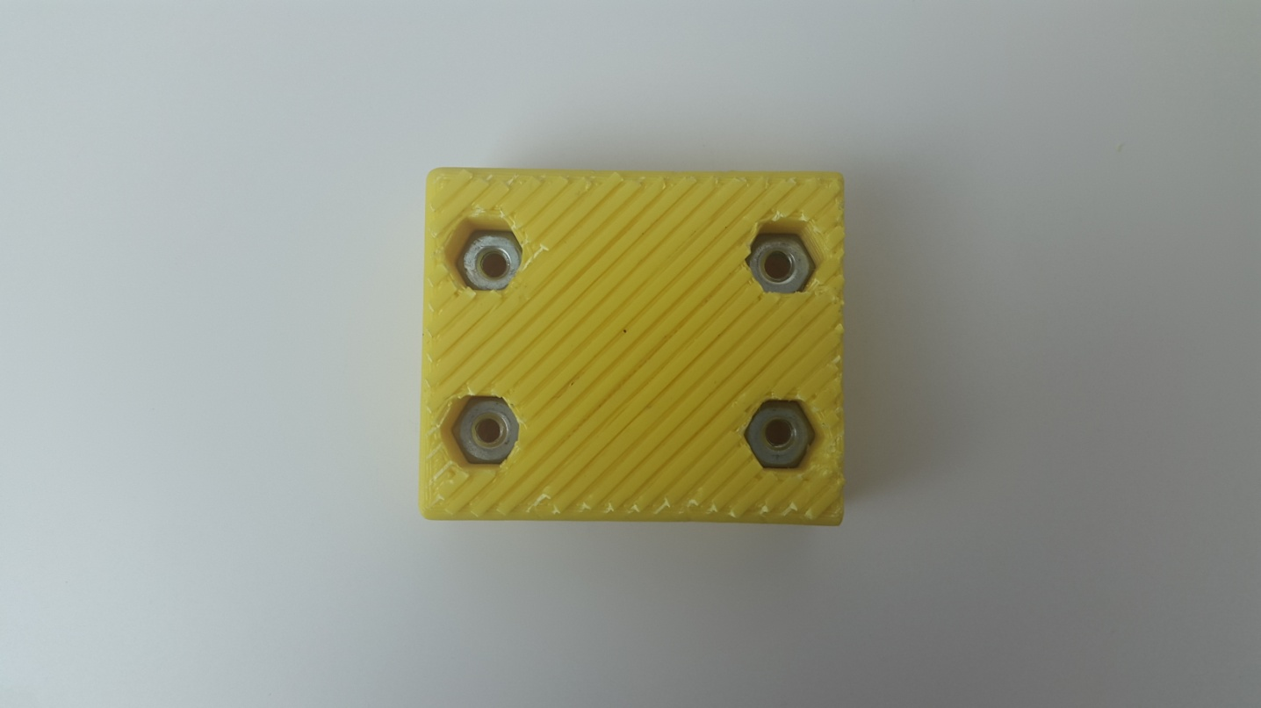

Figure 11 - Glued Nuts in Bottom Piece of Clamp

1. Glue the Female 1/4"-20 to 5/8"-27 Male 2 Piece Mic Adapter into the hole in the assembled 3D printed clamp as shown in the image below.

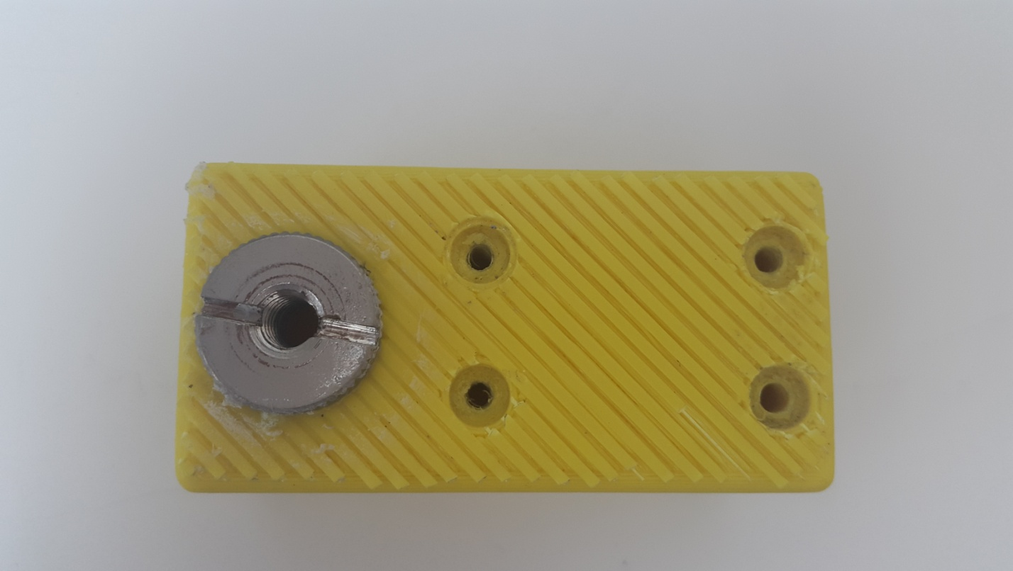

Figure 12 - Glued 1/4"-20 to 5/8"-27 Adapter in 3D Printed Clamp

1. Wrap the 2" piece of Magic Wrap around the section of the tube that you plan on mounting in to.

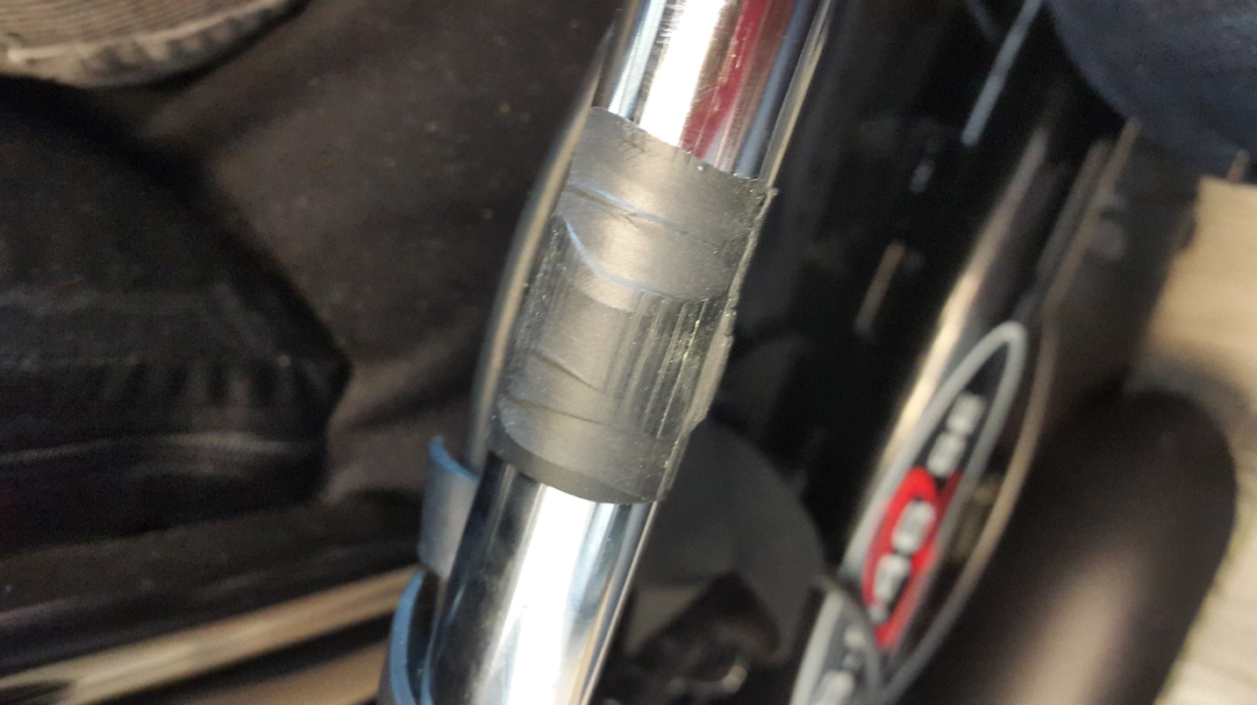

Figure 13 - Magic Wrap Around Wheelchair Tube

1. Place the bottom piece of the clamp on the Magic Wrap.
2. Align the top piece with the bottom piece and screw in the first bolt until it is secure. Repeat for the other 3 bolts.

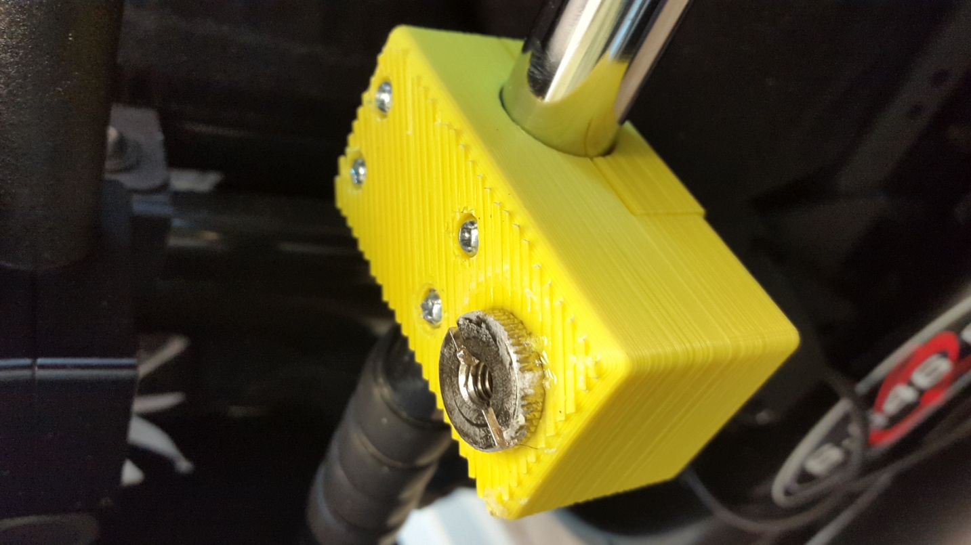

Figure 14 - Complete Assembly of Clamp

# Appendix C - Assembly Instructions for DIY Mount

Tools:

1. Glue
2. Tube Cutter or Saw

Components:

1. (1) 5/16 in.-24 tpi x 1-1/2 in. Hex Cap Screw
2. (1) 5/16 in. Nut
3. 3D Printed Clamp - Files for printing available [here](file:///C:\Users\Jake%20Mclvor\Dropbox\Makers%20Making%20Change\Projects\LipSync\Mounting\Main%20Mounting%20Doc%20&%203D%20Printing%20Docs\3D%20Printing%20Clamp.docx)
4. 3D Printed Disk Gear & Hand Knob - Files for printing available [here](file:///C:\Users\Jake%20Mclvor\Dropbox\Makers%20Making%20Change\Projects\LipSync\Mounting\Main%20Mounting%20Doc%20&%203D%20Printing%20Docs\3D%20Printing%20Disk%20Gear%20&%20Hand%20Knob.docx)
5. 3D Printed Threaded Adapters: 1/4-20 threaded insert & 3/8-16 threaded holder - Files for printing available [here](file:///C:\Users\Jake%20Mclvor\Dropbox\Makers%20Making%20Change\Projects\LipSync\Mounting\Main%20Mounting%20Doc%20&%203D%20Printing%20Docs\3D%20Printing%20Threaded%20Adapters.docx)
6. 11" Inch Friction Articulating Magic Arm for Camera DSLR
7. Arrow Shaft - for the models provided we used an Easton Eclipse 2512 Arrow Shaft

*For the second possible assembly:*

1. *Mini Ball Head with Lock and Hot Shoe Adapter Camera (optional)*
2. *1/4 male to 3/8 male adapter (optional)*
3. *3/8 female to 5/8 male adapter (optiona)*

Steps:

1. Assemble the 3D printed clamp as described in Appendix B Assembly Instructions for 3D Printed Clamp.
2. Screw the 11" Inch Friction Articulating Magic Arm for Camera DSLR into the Mic Adapter in the 3D printed clamp.
3. Determine the length of the arrow shaft necessary by adjusting the articulating arm and approximating the length necessary to reach the mouth of the user. There will be two sections of arrow shafts in total.
4. Use the tube cutter to cut the arrow shaft to size. Make sure to file the ends of the arrow shaft to remove sharp edges.

Note: we found that increasing the length of the arrow shaft increases the vibration of the whole assembly, which makes it difficult to use the LipSync. The maximum suggested length arrow shaft to use is 9".

1. Glue the 3D printed 3/8-16 threaded holder on one end of an arrow shaft.
2. Screw in the 5/8 to 3/8 threaded adapter in the LipSync. Make sure to leave room for the LipSync spacer or to place the spacer in its position.
3. Screw the 3/8-16 threaded holder into LipSync to help with aligning the Disk Gear. Be careful not to over-tighten as to avoid breaking the threaded holder.
4. Place the Disk Gear at the other end of the arrow shaft. Make sure that the side of the disk is aligned with the LipSync as shown in the image below. Glue the arrow shaft in the Disk Gear.

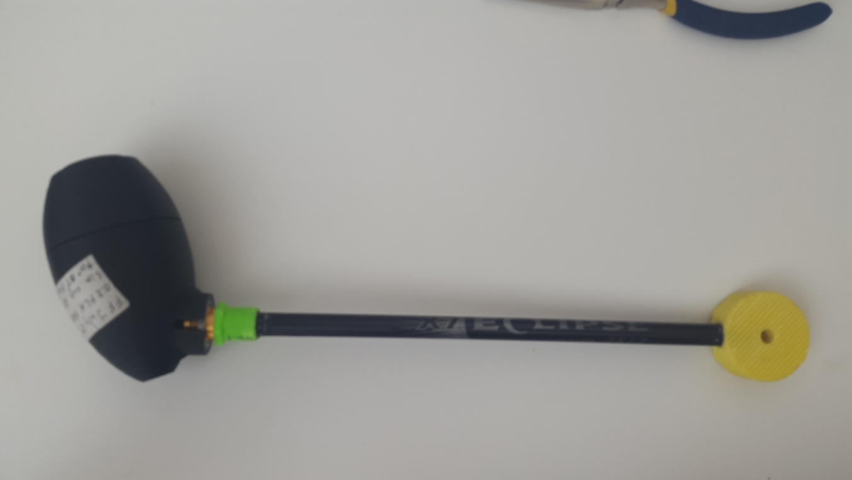

Figure 6 - Disk Gear Aligned with the LipSync

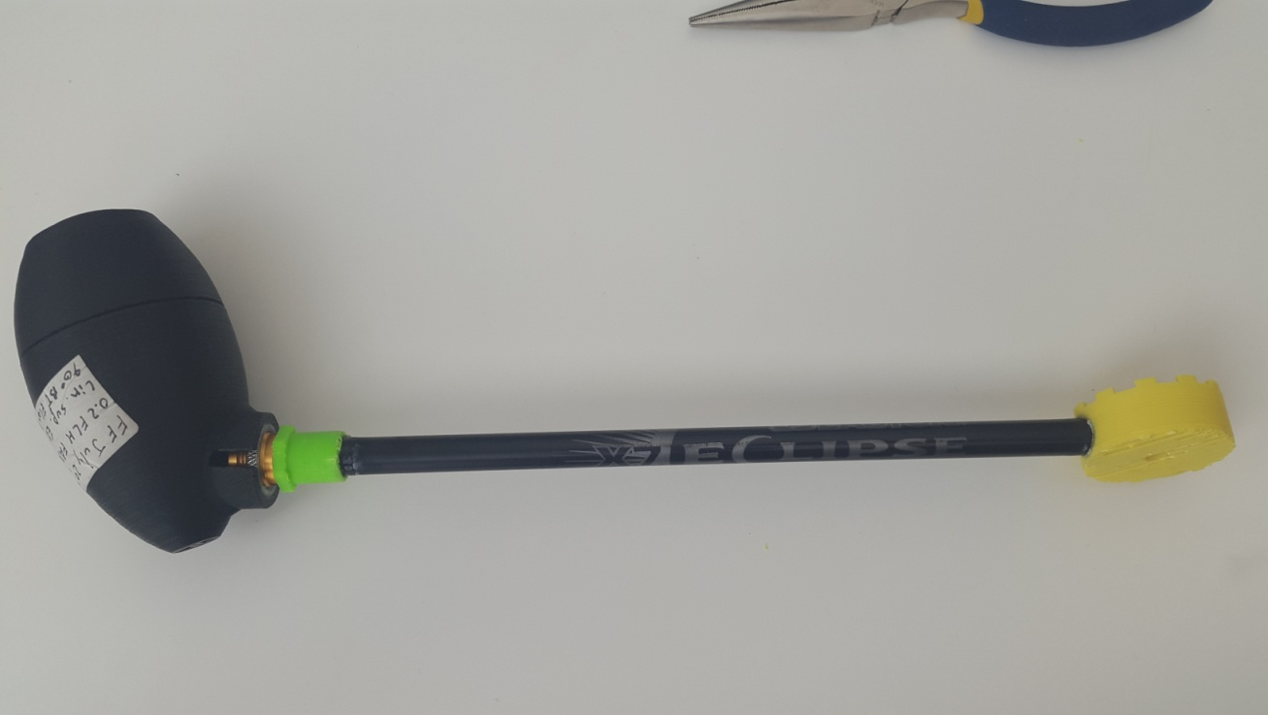

Figure 7 - Misaligned Disk Gear

1. Grab the other arrow shaft and glue the 3D printed 1/4-20 threaded insert.
2. Place the Disk Gear at the other end of the arrow shaft and glue it in place.
3. Place the Articulating Magic Arm onto the arrow shaft with the 1/4-20 threaded insert by threading it into the arrow shaft. It is advisable to glue the 1/4-20 insert to the Articulating Magic Arm to provide stability to the assembly.
4. Glue the 5/16 in nut int the 3D printed hand knob.

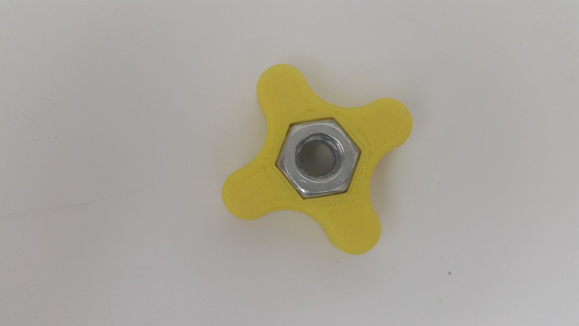

Figure 9 - Glued Nut in 3D Printed Hand Knob

1. Attach the second arrow shaft to the first by meshing the Disk Gear together. Use the 5/16 in.-24 tpi x 1-1/2 in. Hex Cap Screw and the Hand Knob to tighten the disk. You can glue in the Hex Cap Screw to keep it in place.

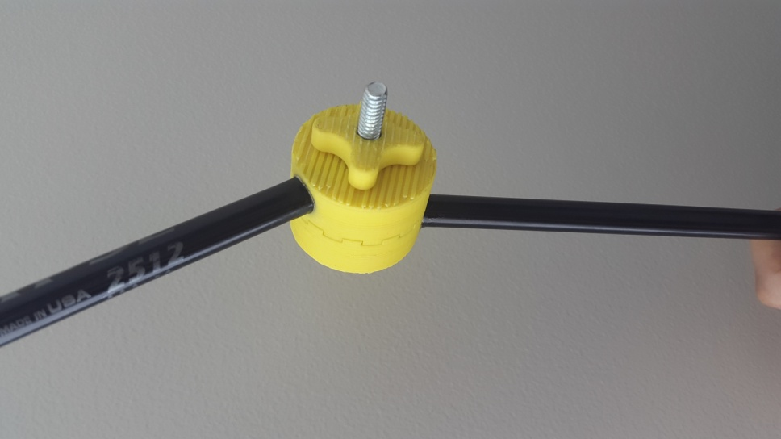

Figure 11 - Disk Gear Used to Adjust the Angle of the Arrow Shafts

1. Use both the Disk Gear and the Articulating Arm to adjust the angle of the LipSync.



3/8-16 Insert

Disk Gear

Arrow Shafts

1/4-20 Insert

Articulating Arm

3D Printed Clamp

*For the optional component:*

1. *Follow steps 1-4 outlined above.*
2. *Glue in the 3D printed 1/4-20 threaded insert on one end of an arrow shaft.*
3. *Glue in the bottom piece of the Disk Gear at the other end of the arrow shaft.*
4. *Grab the other arrow shaft and repeat step 2.*
5. *Glue the top piece of the Disk Gear at the other end of the arrow shaft.*
6. Place the Mini Ball Head with Lock onto the other arrow shaft with the 1/4-20 threaded insert by threading it into the insert. It is advisable to glue the 1/4-20 insert to the Mini Ball Head with Lock to provide stability to the assembly.
7. Thread the 3/8 female to 5/8 male into the LipSync. Thread the 1/4 male to 3/8 male adapter into the adapter in the LipSync.
8. Thread the Mini Ball Head into the LipSync and adapter assembly.
9. Follow steps 12-13 outlined above.
10. Use the Disk Gear, Articulating Arm, and the Mini Ball Head to adjust the angle of the LipSync.

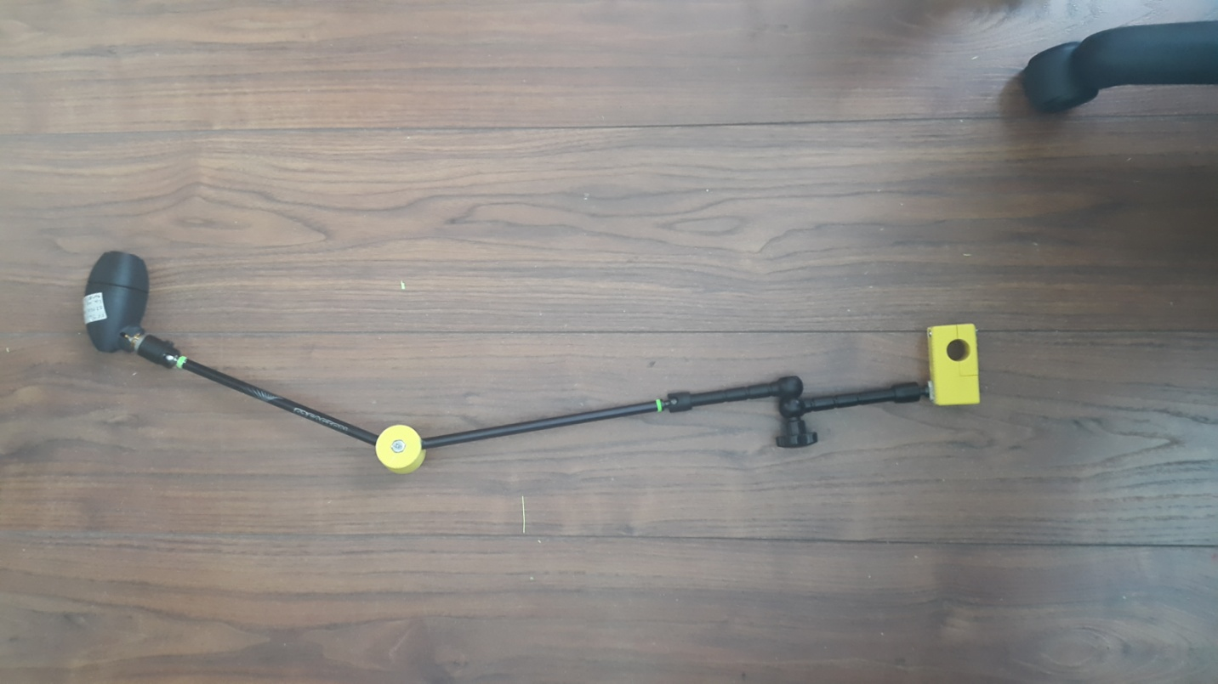

Mini Ball Head With Lock

Figure - Complete Assembly of DIY Mount With Mini Ball Head

# Appendix D - Field of Vision Claculations

